 | User Manual  of  Mid Day Meal Scheme

State Level User
Below are state level functionalities.
- User Management
  - Create User
  - Change Password

- Master Entry
  - Norms Master
  - Lifting Agency Masters
  - District Working Days
  - Opening Balance
  - MDM Menu
  - Annual Data Replication
  - View Cooking Cost Norms

- School Data Entry
  - Inspection
  - Unfreeze Monthly Data
  - Unfreeze School Opening Balance

- AWP & B
4.1 District AWP&B Plan Submission
4.2 State AWP&B Plan Submission
4.3 Quantification of Central Assistance

- Fund
  - Fund Receive
  - Add State Share
  - Fund Release
  - Non Recurring Fund Receive
  - Kitchen Device – Add State Share
  - Kitchen Cum Store – Add State Share
  - Non recurring Fund Release

- MME
6.1 MME Details

- Food Grain Release
7.1 Food Grain Release

- Food Grain Management
  - Indent Generation
  - Supply Agency Lifting Details
  - Supply Agency bill Generation
  - Supply Agency Bill Payment

- Lifting Agency
  - Bill Generation
  - Bill Payment

    - User Management:

User have two functionalities in user management
                - Create User
                - Change Password

State level user can create district/block /school level user.

1.1. Create User

User have to go User Management -> User Creation
On click on User Creation menu this screen will come

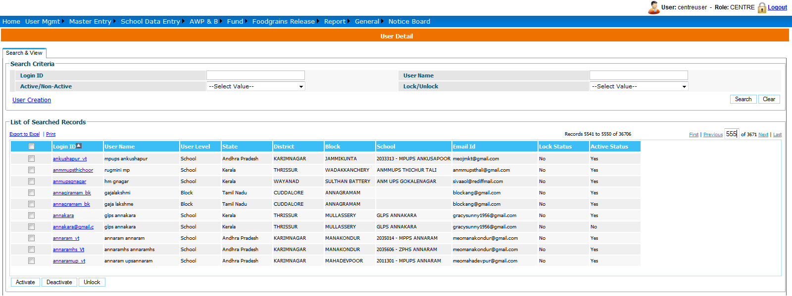

User have three option on screen.
    - Add User
    - Activate
    - Deactivate

If user wants to create new user then he has to click on User Creation. Following screen will
Appear to user.
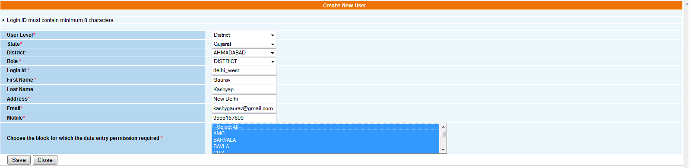

User has to select user Level (District/Block/School), Role (DistrictAdmin/BlockAdmin/SchoolAdmin).

If user select District level - he has to select state and district name from list
If user select Block level - he has to select state, district and block name from list
If user select School level - he has to select state, district, block and school name from list

User has to fill all required details like login id, first name, address and email.
After entering all details click on Save.
On save new user will be created on password wil sent on given email id.

If user want to edit any user then click on user name , new screen will be open with all details of user. User can make changes and click on update to save the details.

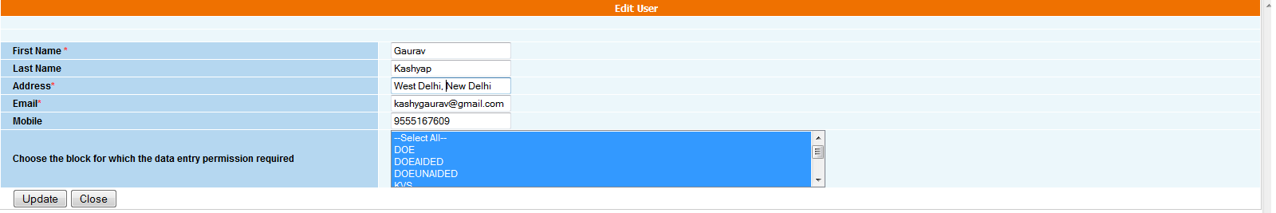

If user want to activate or deactivate any user then

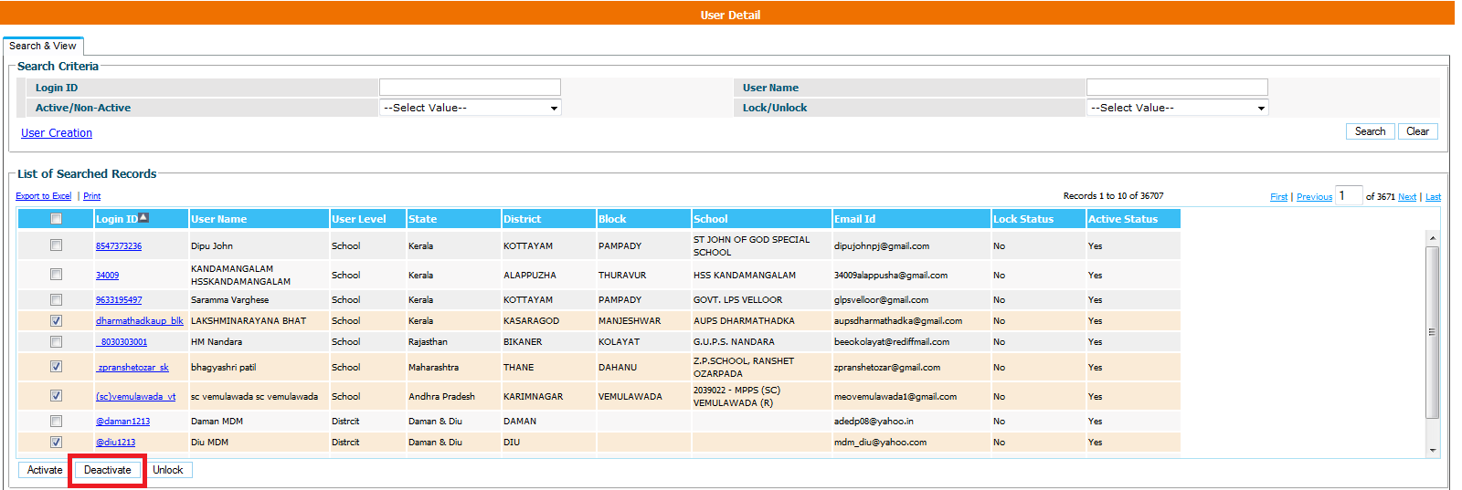

User has to click on check box for which user he want to deactivate. If user is already deactivated then user has to click on activate button

1.2. Change Password

To change his/her password
User Management → Change Password
On click on change password following screen will appear

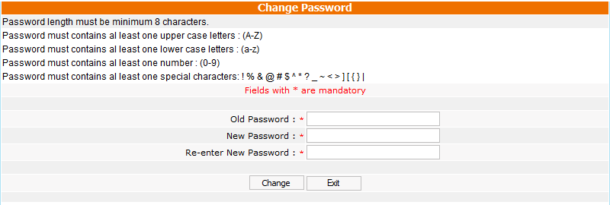

User has to enter old password, new password. On click on Change button password will change and new password will be send as email.

- Master Entry:

2.1 Norms Master

The State level user selects financial year and clicks on Add Norms to save the norms. User can save norms in Draft mode to modify the further or Freeze. Once the status of norms is Freeze no further changes can be made in them.

  - Lifting Agency Entry

2.2.1 Lifting Agency Entry:
When user clicks on Lifting Agency Entry, list of all Lifting agencies of that State/UT is reflected to his/ her. User can update information of lifting agency on clicking Edit. The user can create new Lifting Agency on clicking Add New Agency. Below screen is reflected to user.

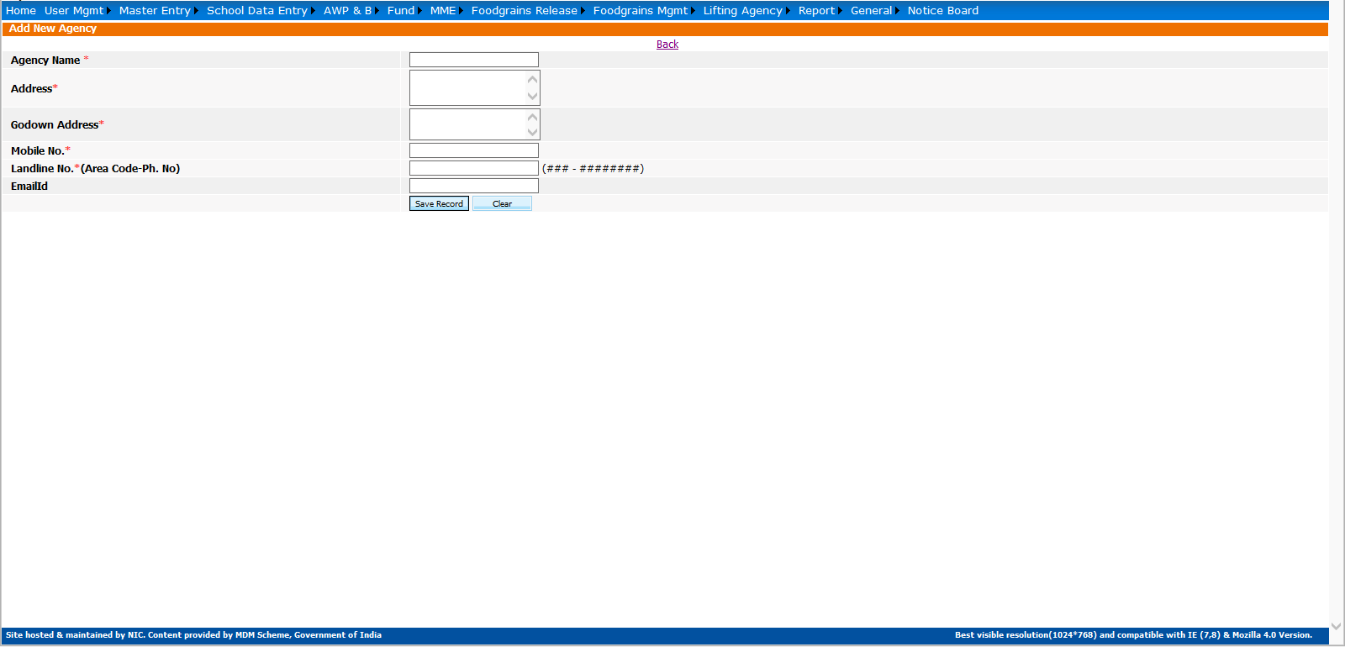

User enters all necessary details & clicks on Save Record to generate new lifting agency.

2.2.2 Add lifting Agency Mapping:
When user clicks on it, list of all lifting agency is populated to user. User can clicks on particular lifting agency name, below screen is reflected to his/her.

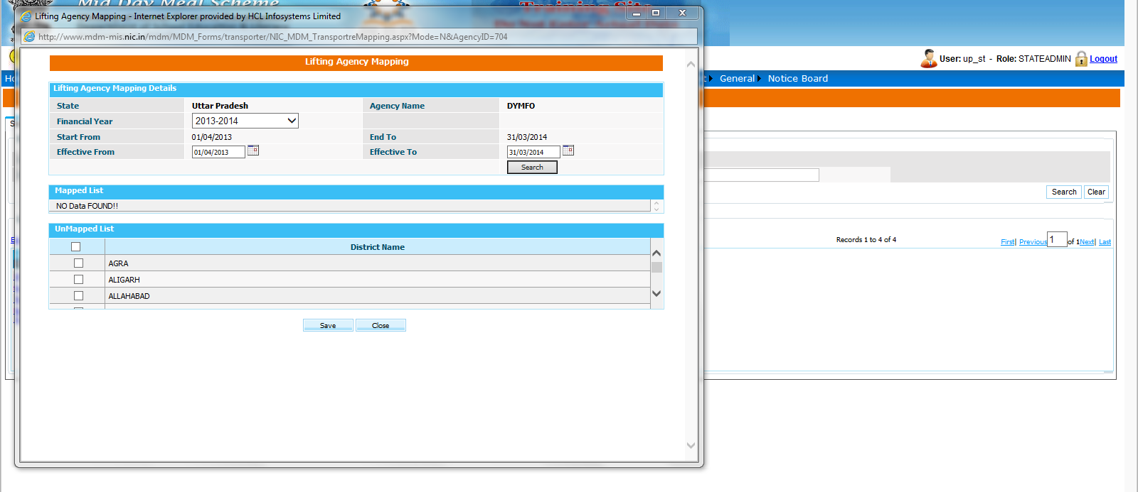

User provides all relevant information and clicks on Save.

  - District Working Days:

When user selects financial year, school category and clicks on Add District wise Calendar below screen is reflected to his/her.

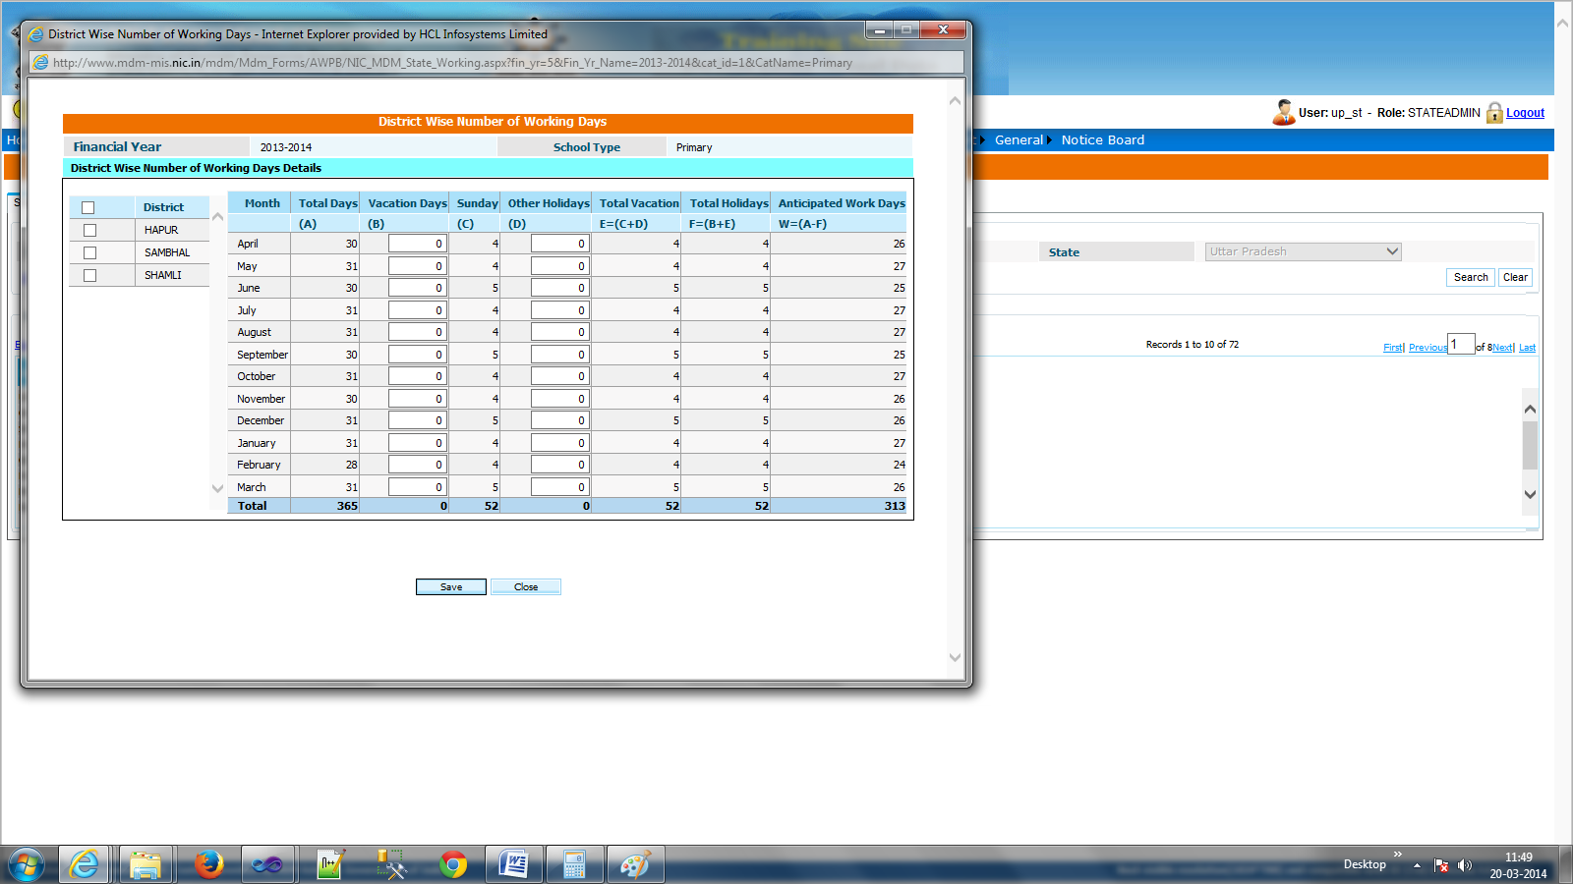

User provides all relevant information and clicks on Save.
When user selects financial year, school category and clicks on Search list of Category wise calendar appeared to his/her. User can modify calendar on clicking either Edit District or Edit Calendar.

  - Opening Balance:

This screen is for making entry of opening balance of various fund & food grain components.

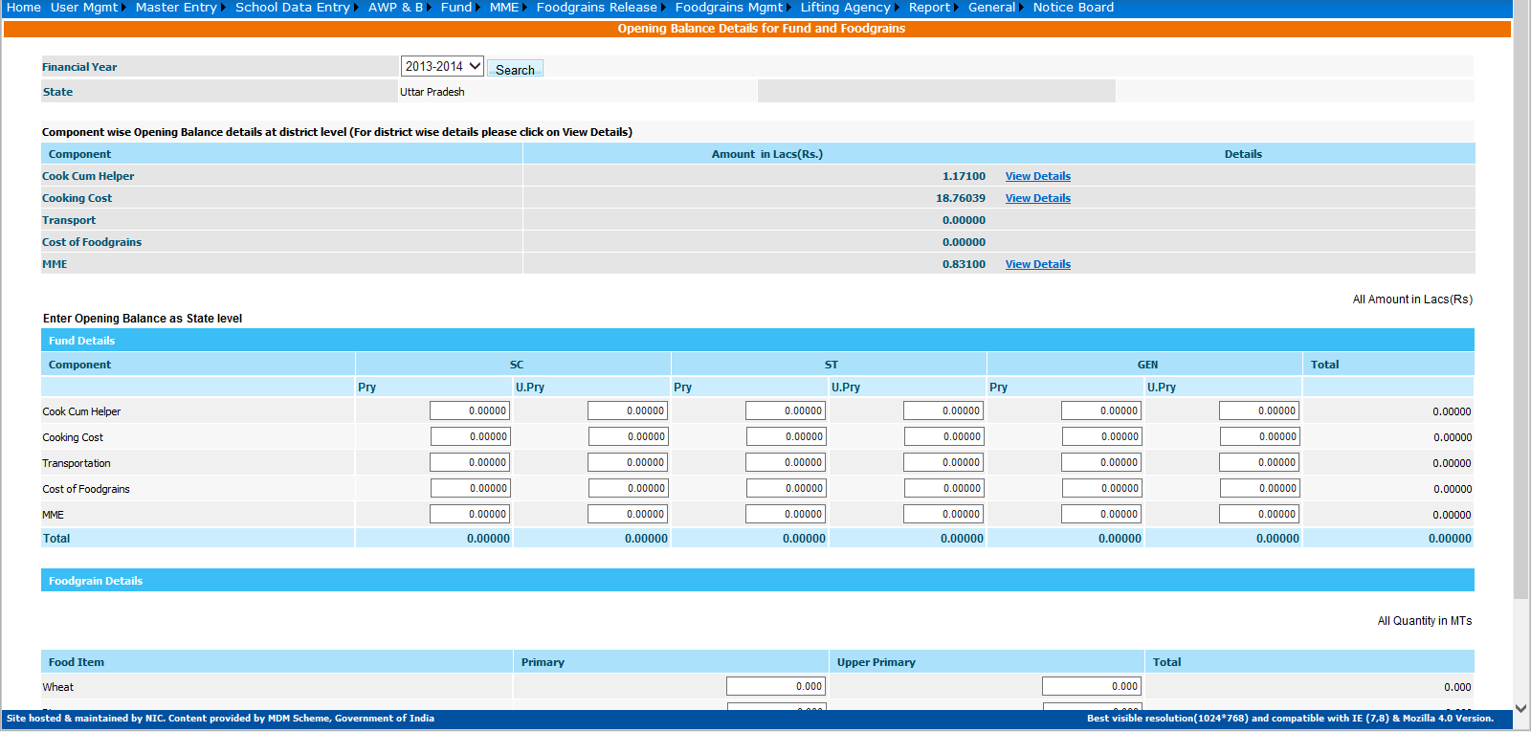

  - MDM Menu:

User selects financial year, and clicks on Add Menu to save the weekly menu details.

  - Annual Data Replication:

This screen is for replicating Annual Data from previous financial year to current financial year.

  - View Cooking Cost Norms:

When user selects financial year clicks on Search list of cooking Cost norms is appeared to his/her. User can view details of cooking cost norms on clicking View details.

User can save additional cooking cost norms (Second slab norms) on clicking Add New Cooking Cost Norms.

- School Data Entry

3.1 Inspection
This screen is for entering school inspection details. User selects financial year, District, Block, school name & clicks on Add inspection Details, a new screen is populated to his/her. User enters all necessary details & clicks on Save.

3.2 Unfreeze Monthly Data
This screen is for Unfreezing monthly data status on request from District/Block/School level User.

3. 3 Unfreeze School Opening Balance
This screen is for Unfreezing opening balance status on request from District/Block/School level User.

- AWP&B

To implement MDM scheme states submit their proposal at the start of financial year. Centre has responsibility to analyze state proposal as per current financial year utilization and approve state plan for next financial year.

4.1 District AWP & B Plan Submission
Select District Wise AWP & B Plan Submission sub menu under AWP & B Menu as mention below:
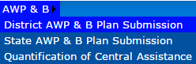

After click on above link, following screen appears

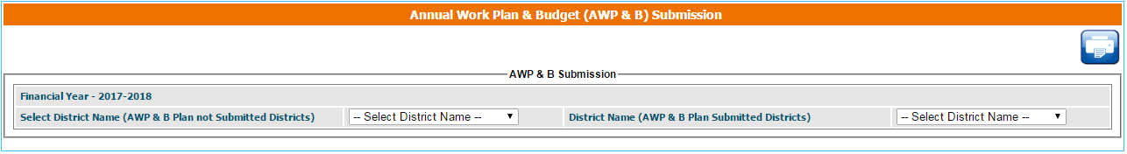

Select district name from not submitted district name combo list. After selecting district name entry screen display following components:

Recurring
(A-1) Children: Enter enrolment on 30 September 2016, Last PAB Approval 2016-17, Avg. No. Children Availed MDM and Proposal for 2017-18.
- (A-2) Working Days: Enter Last PAB Approval 2016-17 Working Days, No. of Working Days on which MDM Served and Proposal for 2017-18.
- (A-3) Cook Cum Helper: Enter Last PAB Approval 2016-17 CCH, No. Of CCHs Engaged and Proposal for 2017-18.

Enter all above figures in Numbers

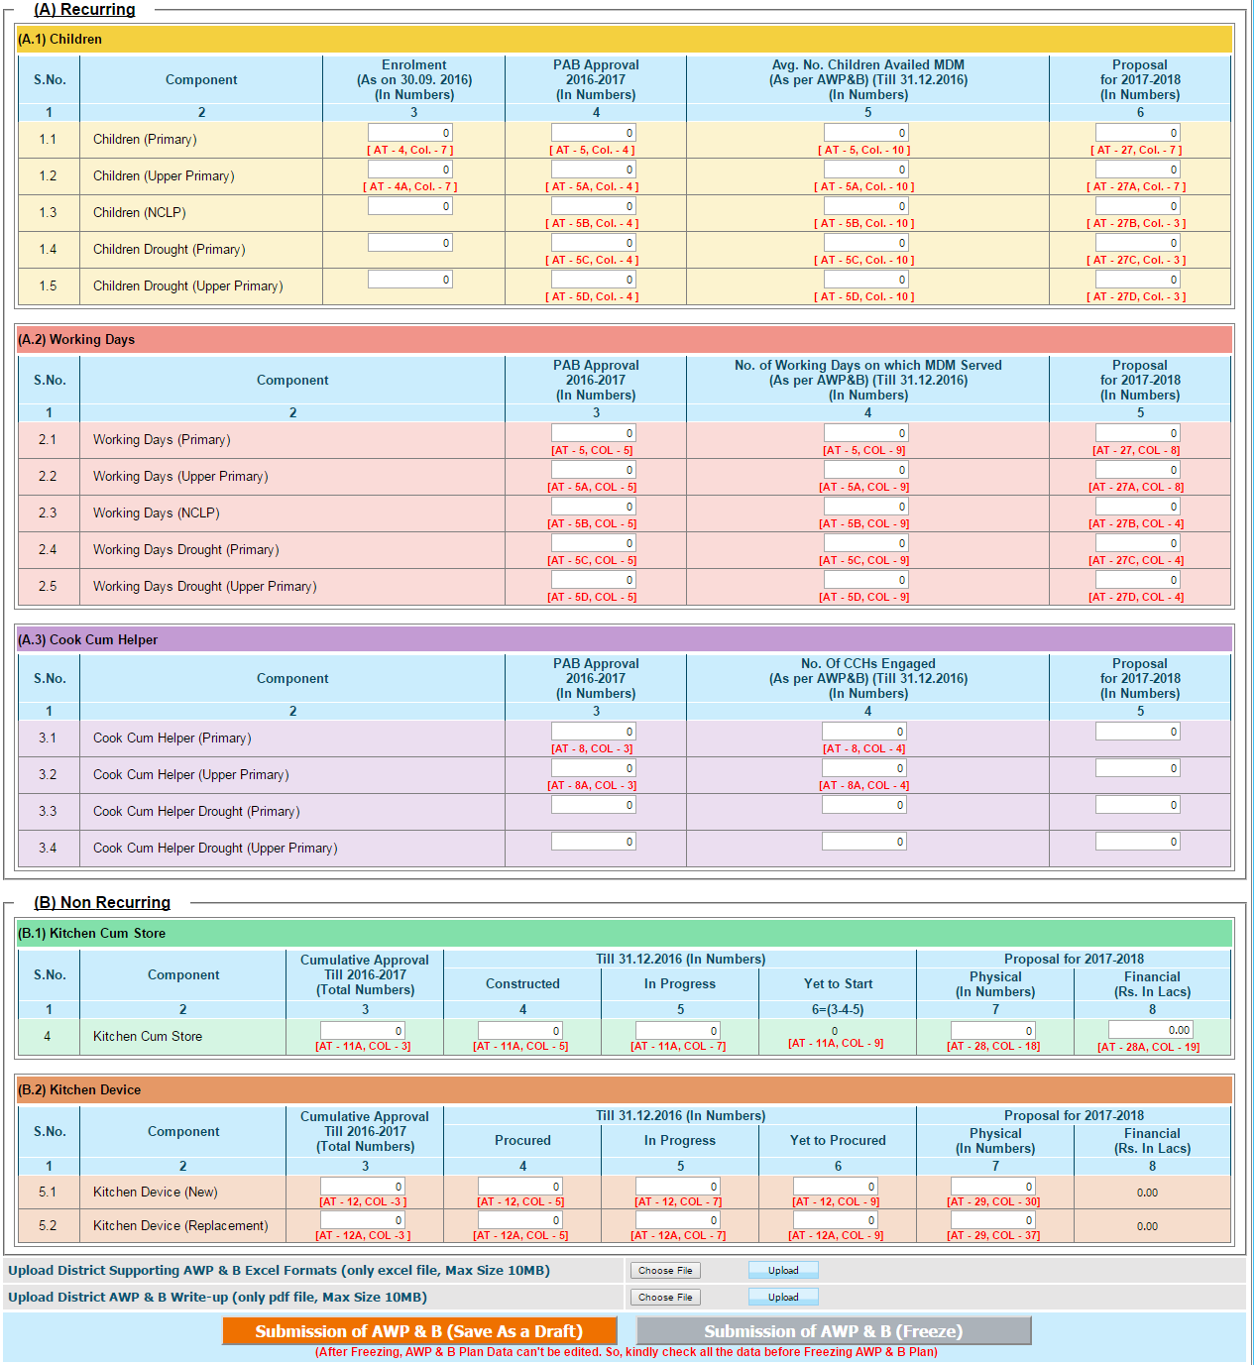

(B)Non Recurring
Kitchen Cum Store and Kitchen Device: Enter Cumulative Approval, Constructed/ Procured, In Progress, Yet to Start/Procured, Proposal Physical (In Numbers), Total Amount Proposed Financial
(Rs. In Lacs).

If user has not all the data of particular District, then you can save form data in Draft Mode, so that user can edit or enter data later. Upload District AWP&B Supporting excel formats (only excel file) and write-up file (only pdf file).
After filling all data and uploading documents, freeze button will be enable and freeze District Plan Data. Freeze all Districts Data.

4.2 State AWP&B Plan Submission
After freezing all Districts Plan select following option from Menu

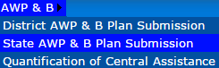

Cumulative Final Annual Work Plan & Budget (AWP & B) Submission by State / UT
Page shows all Districts Data.
There is three flags before freezing State AWP&B Plan :
All Districts had freeze Plan Data.
State Upload Supporting Documents.
State freeze Norms for next Financial Year.
If all of above condition true, then State can freeze AWP&B Plan Data.

Kindly rectify this data before submit plan. After all districts plan submission state can upload Supporting AWP&B Excel Formats (only excel file, Max Size 10MB) and AWP&B Excel Write-up (only pdf file, Max Size 10MB).
State can enter remark corresponding to component column.
State can save Plan in draft mode for further modification or can freeze plan after validating all data.
After freezing data, state can’t edit the data.

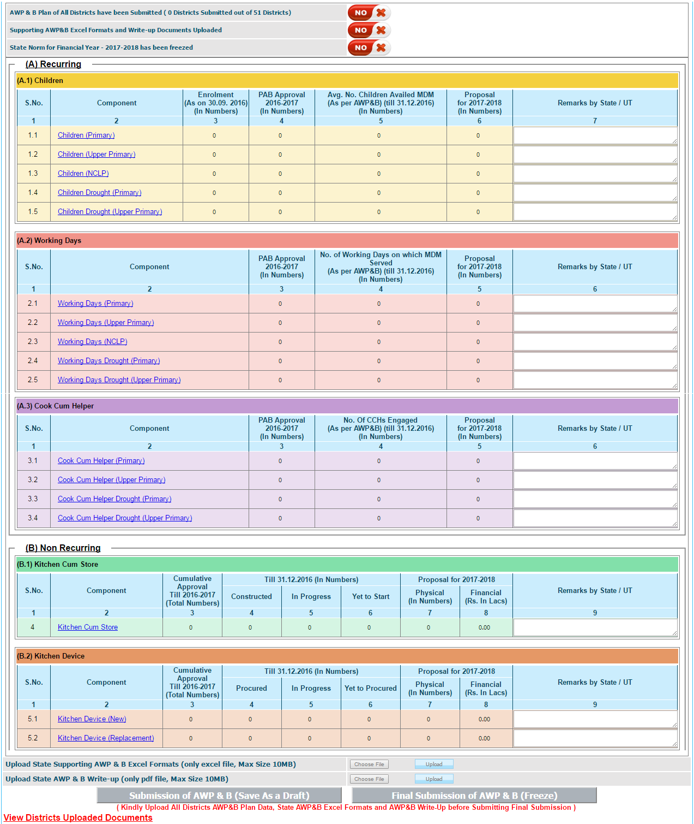

4.3 Quantification of Central Assistance

After freezing State AWP&B Plan, State can check Quantification of Central Assistance in different component.

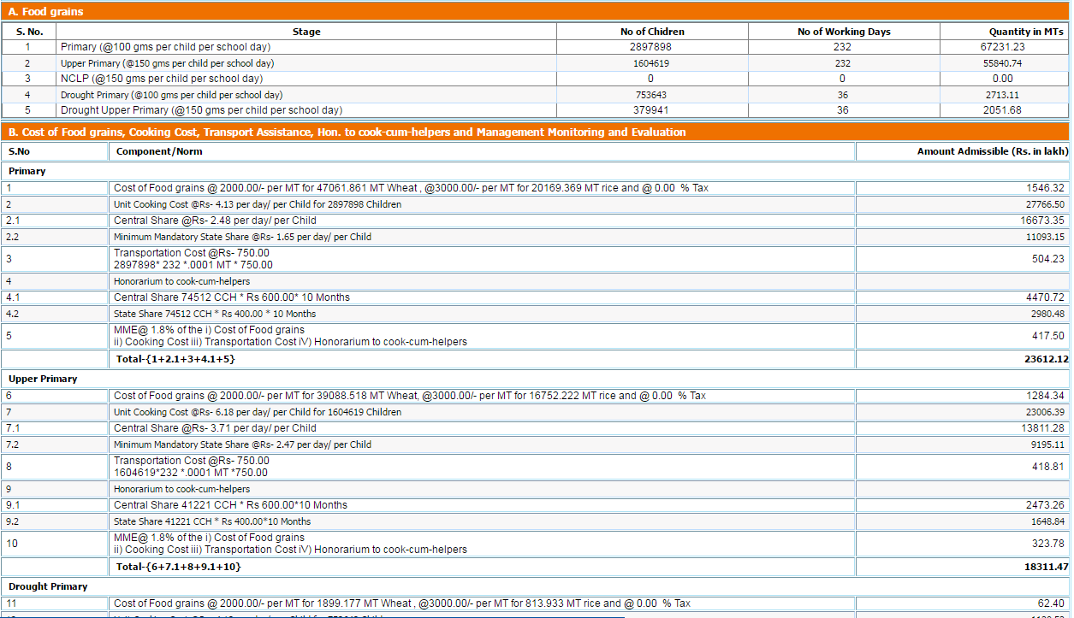

State can check Quantification of central assistance on the basis of Plan submitted by State, Plan recommended by appraisal team and Plan approved by PAB.

- Fund

5.1 Fund Receive

User selects financial year and clicks on Search a list of fund released from centre to state will appear. If status of Receive is received then it means this fund has been received, if status of Receive is yet to be received then it means this fund has not been received. User clicks on yet to be received to receive this fund, and then following screen will appear.

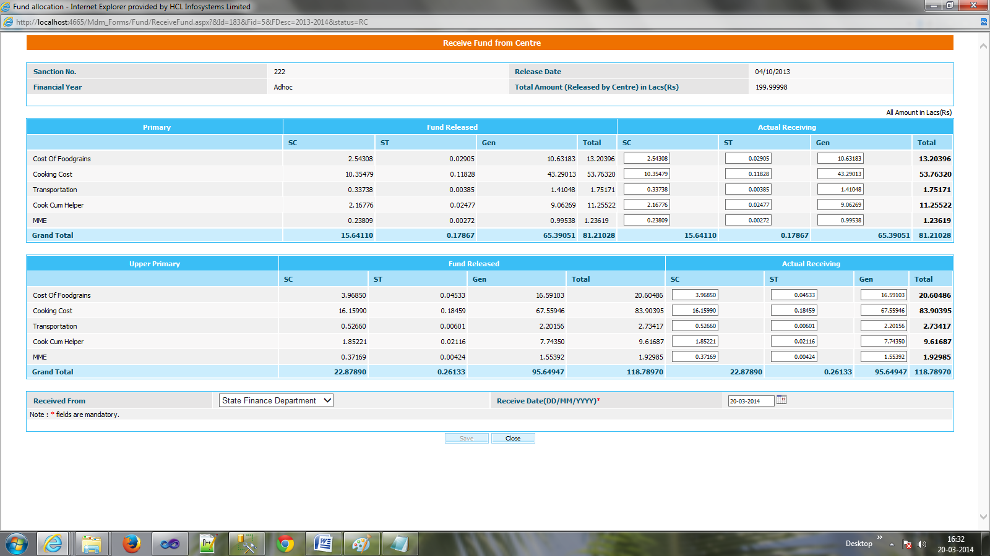

User click save to receive the fund.

5.2 Add State Share

User selects financial year and clicks on Add state Share Below screen will appear. User enters necessary values in different fields and clicks either on Save as Draft or Save to modify it later or release it to its own.

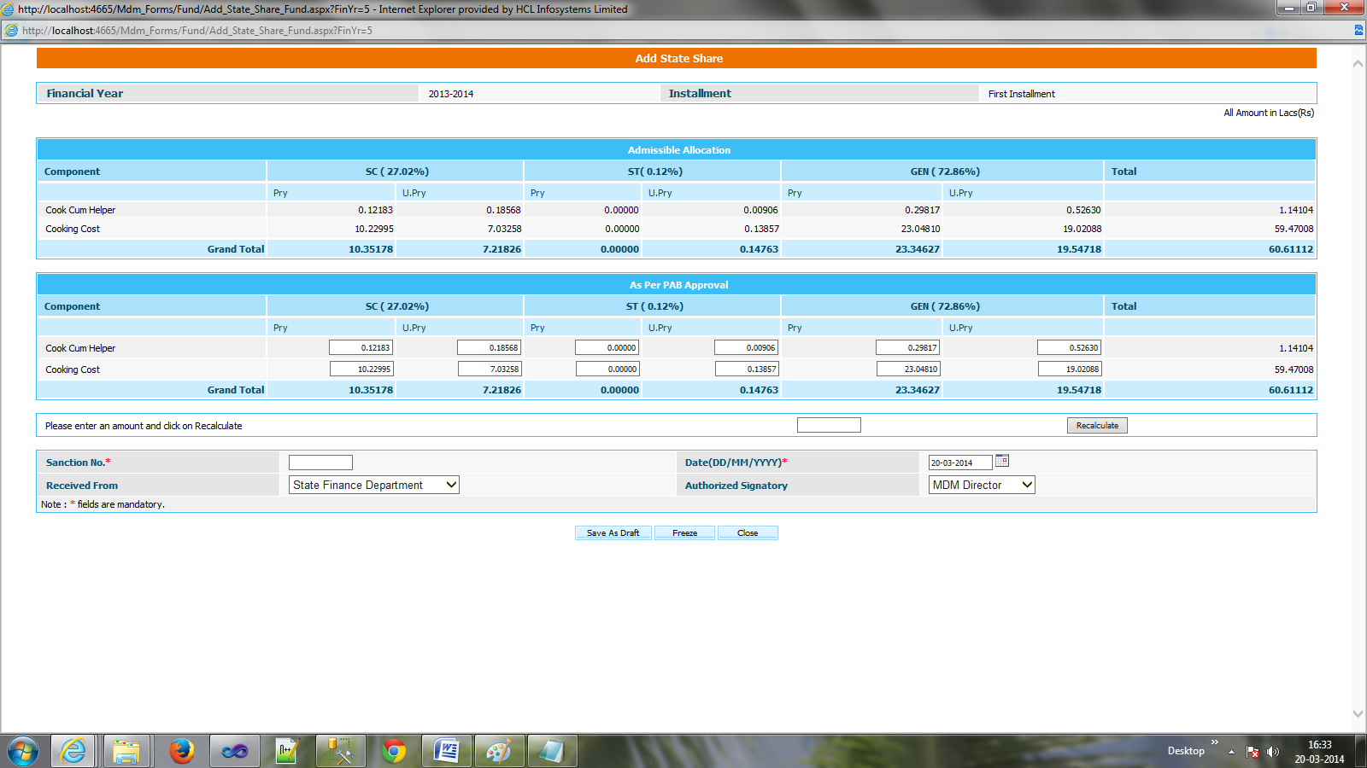

When user selects financial year and clicks on Search a list of fund released from its own to it will appear.

5.3 Fund Release

User selects financial year and clicks on Add New Release a screen will appear. User selects component name, district name and enters necessary values in different fields, clicks on Add Row and clicks either on Save as Draft or Save to modify it later or release it to selected district.

If user has clicked save then it will redirect to his/ her previous page and status of release will be yet to be released. User clicks yet to be released to release it to district & status will get convert in Released.

User selects financial year and clicks on Search a list of fund released from state to district will appear. User can get details of release on clicking Complete.

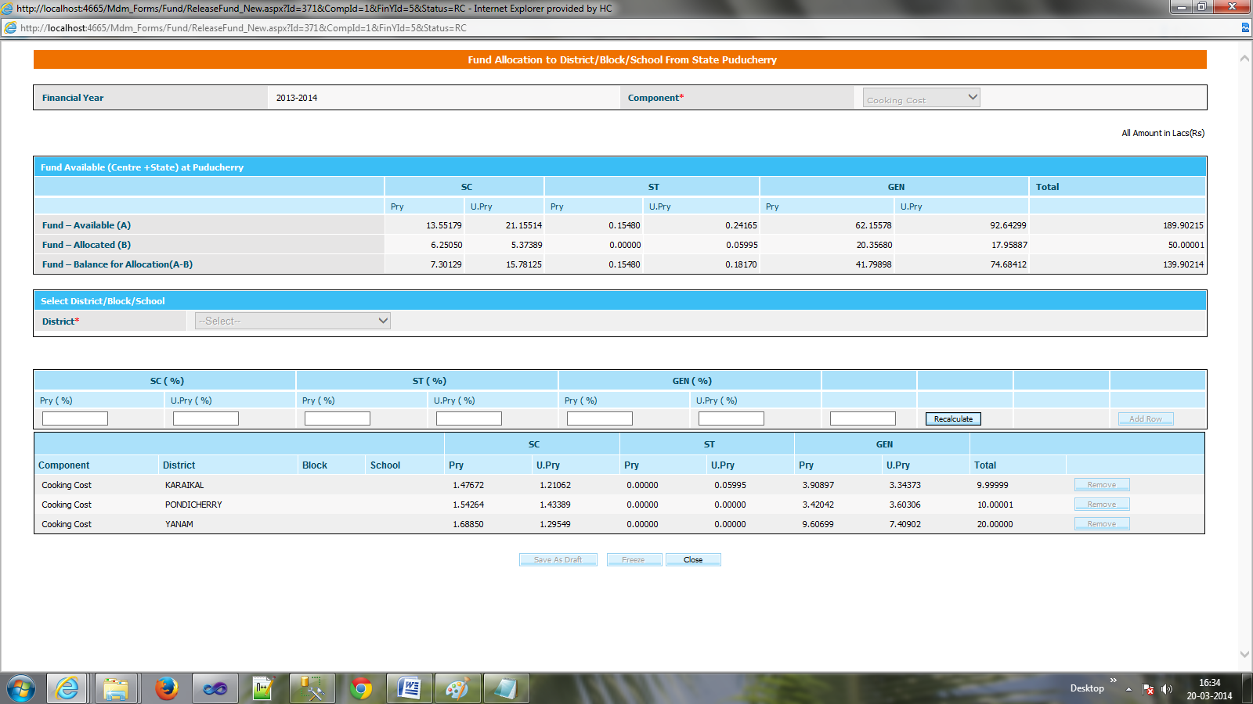

5.4 Non Recurring Fund Receive

User selects financial year and clicks on Search a list of fund released from centre to state will appear. If status of Receive is received then it means this fund has been received as shown in figure.

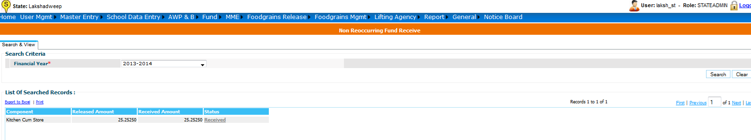
if status of Receive is yet to be received then it means this fund has not been received. User clicks on yet to be received to receive this fund, a screen will appear, user will have to click on
Save button to receive the fund. Status of component will get change from yet to be received to received.

5.5 Kitchen Device – Add State Share

To add kitchen device state share
User----------Select Financial year---Add state share

Following screen will appear to user

Screen shows admissible allocation for kitchen device, no of approved school. User can modify kitchen device PAB approval amount & can save it Save as Draft or Freeze mode.

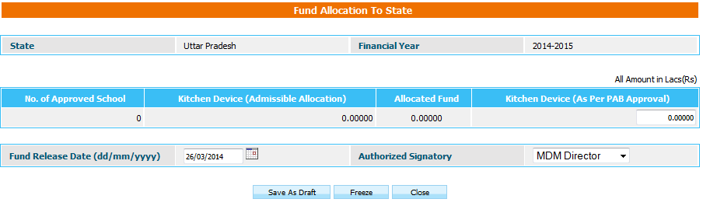
After successful freeze a list will appear to user in which entry of status column will be release.

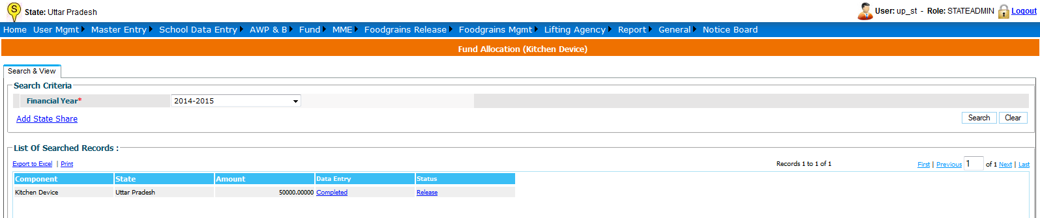

On clicking “Release” fund is finally released to State. A message will be shown on a pop up window.

5.6 Kitchen cum Store- Add State Share

To add kitchen cum store state share
User----------Select Financial year---Add state share

Following screen will appear to user
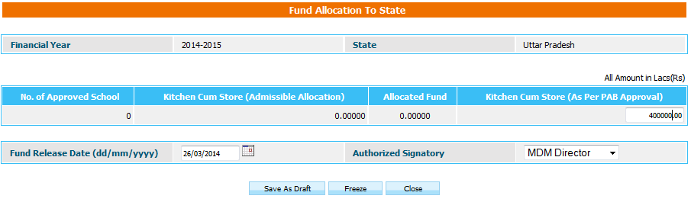

Screen shows admissible allocation for kitchen cum store, no of approved school. User can modify kitchen cum store PAB approval amount & can save it Save as Draft or Freeze mode.

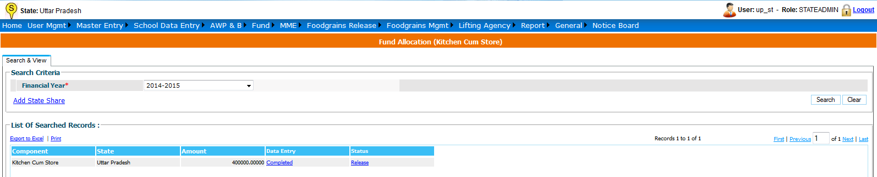

On clicking “Release” fund is finally released to State. A message will be shown on a pop up window.

5.7 Non Recurring Fund Release to District

User selects financial year and clicks on Search a list of records appear those Districts Non Recurring Fund Released. For Add State Share click on “Add New Release” and then following screen will appear. Fill State Share form and save form.

Select Component and District in the following form and releasing amount.

To release Non recurring fund to district
User----------Select Financial year---Add new Release

Following screen will appear to user

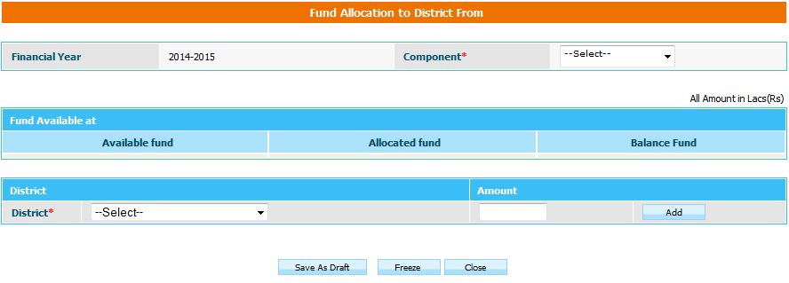

As soon as user select component name (Kitchen device/ Kitchen cum store), Available fund, Allocated, Balance fund for that component is reflected in grid.
User--- select district---------enter amount--click add row--- Save as draft/ Freez

User can release fund to multiple district at a time. On successful freez status of entry in grid will be Release. User has to click on Release to release fund to district, status of entry will get convert from Release to Released.
6. MME

6.1. MME Details

User selects financial year and clicks on Search a list of MME expenses appear. Status of mode may be following.
Drafted: Data may be modified on clicking on it.
Freezed: User can only view the data.

To make new entry of MME expenses user clicks on “Add Expenses” , following screen will appear.

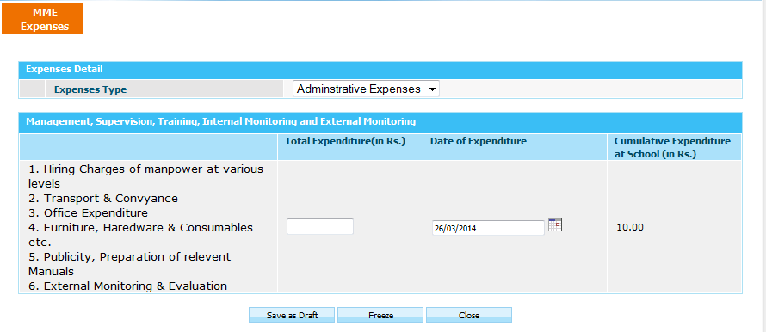

User selects Expense Type, enter expenditure and enter Date of Expenditure & can save data in following mode.

Save As Draft: This option will save the record in draft mode. The user can make any change later. A message appears on successful save.

Freeze: Further modification is not allowed once record saved. A message will appear on successful save.

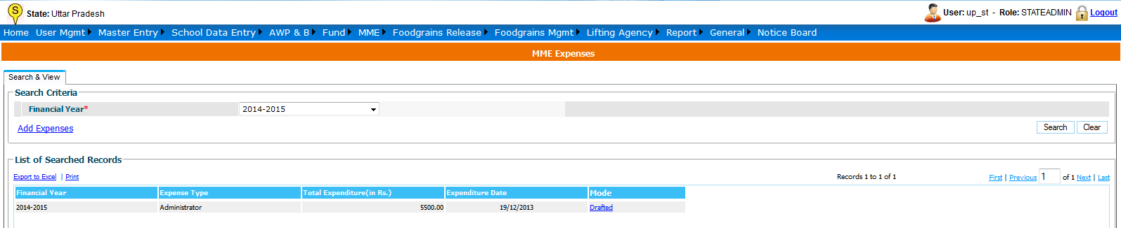

7. Food Grains Management

MDM food grains management module is all about managing food grain. The food grain is released in two components Wheat and Rice.

State user---Food Grains Release -> Food grain Release ---Select Financial Year & Allocation---Search

Following screen will appear.

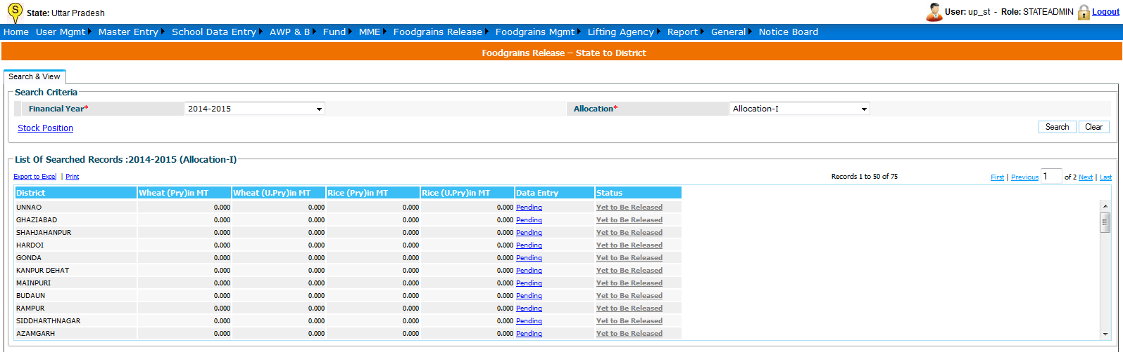

The list will show list of states with Quantity released (if any). The Data Entry column can be show three status.

Pending – Food grains is yet to be released to state.
Saved As Draft --- Food grains Data is saved but the user can modify it.
Freezed – Food grains had released to district level.

Status column will show two statuses:
    - Yet to be released – Food grains has not been released to district level.
    - Released – Food grains has been released to district level.

When user clicks on “Pending”, Food grains Allocation Screens opens, which consists of following sections.

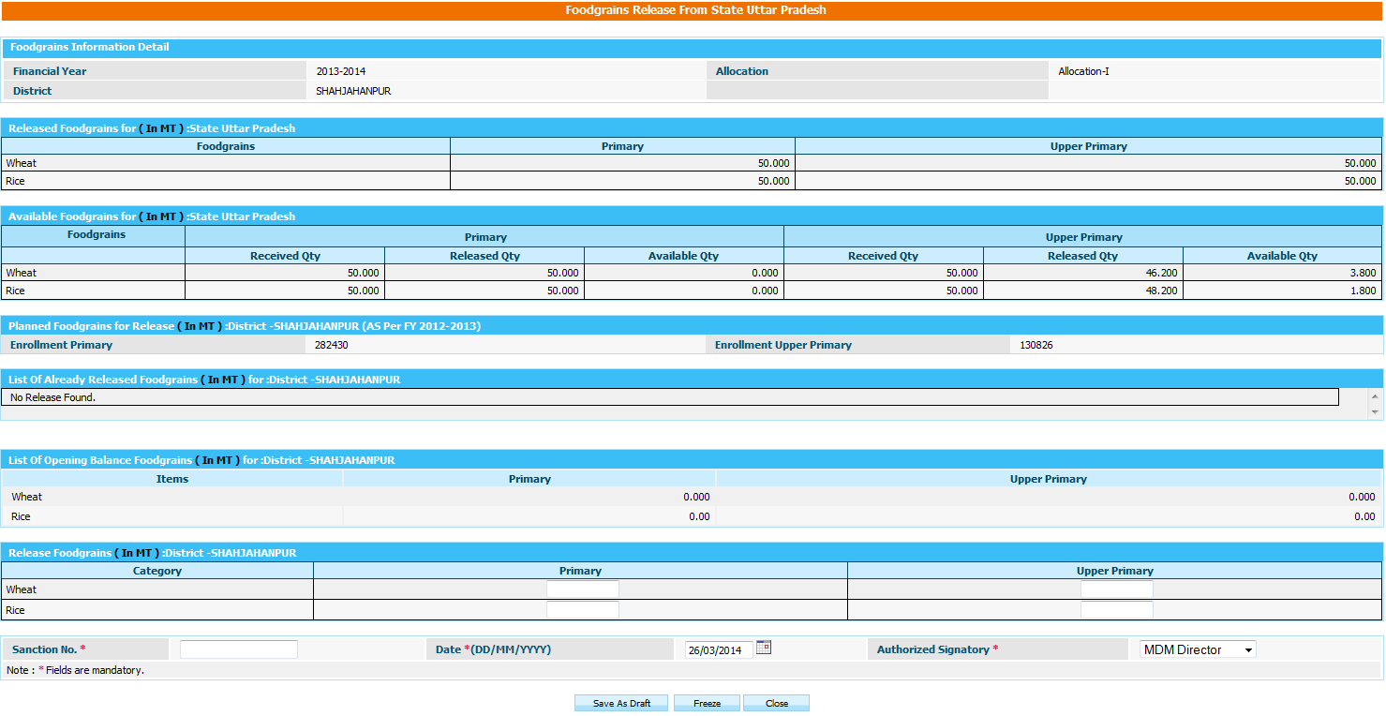

Planned Food grains for Release (in MT):
This section shows quantity to be released as per plan.

List of Already Released Food grains (in MT):
This section shows what quantity already released.

Released Food grains (in MT):
This sections what quantity to be released to state.

After fill the data, user has to click on
    - Save As Draft(Released to be draft mode) Or
    - Save.

The User should enter a release Amount for primary and upper primary quantity of wheat and rice. Sanction number, date and select any authorized signatory and click on “Freeze” or “Save As Draft”.

Alphabets, numbers and “-” and “/” characters are allowed in sanction number.
Date should be in DD/MM/YYYY format and cannot be future date. All dates will be in current financial Year.

If user clicks Save as Draft, it is will be in drafted mode. User can make changes later.
Data entry status will be changed as Drafted. If user wants to make changes click on Drafted link, popup will open. User can make modification in data whenever required.

If user has done all required change and wants to release to state then he has to click on Freeze.

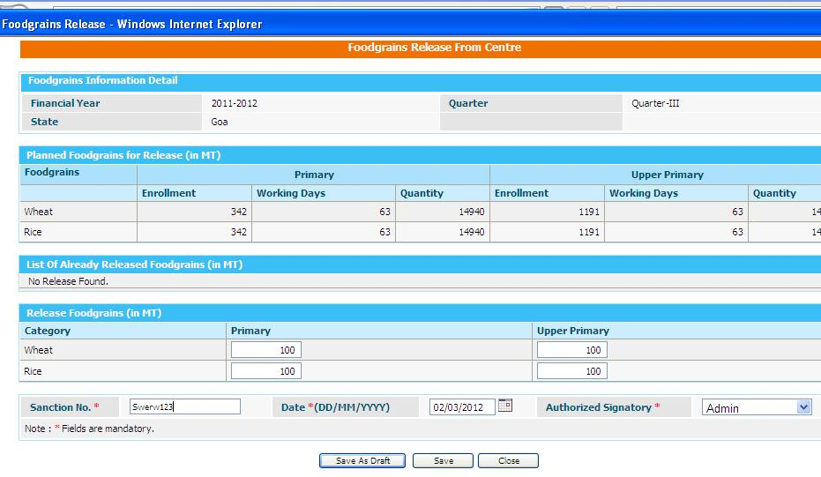

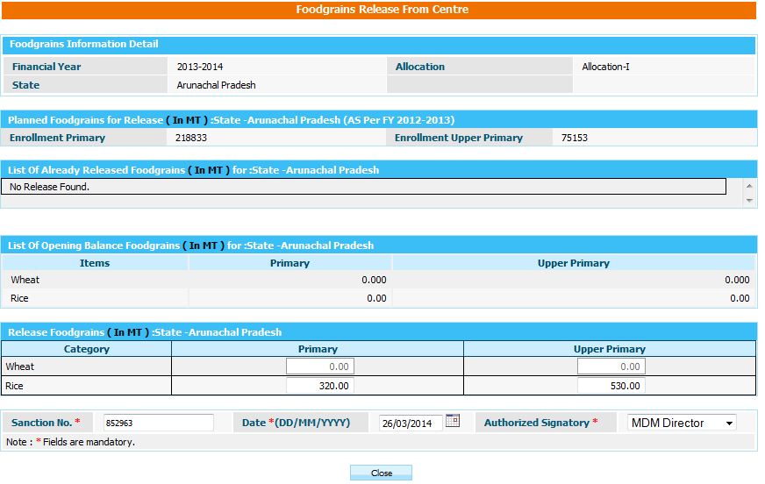

Data will be in completed status but link will be disabled so user can't make any changes.
Status will be “Yet to be Release” and now this link will get enable.
On Clicking Yet to be Release link its status will get changed to 'Released' and it will be Available to state to release.
If there is any quantity is to be pending for release for state 'Data Entry' status will now be as mark as 'Pending' otherwise it shows 'Completed'.

User has one more option in food grains manage. User can check stock position till school level.
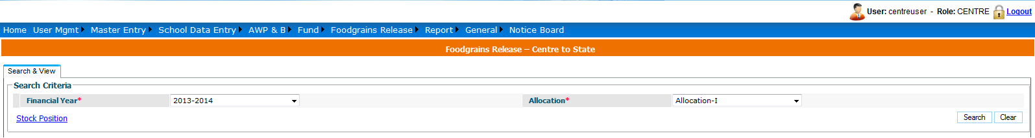

User click on Stock Position link then

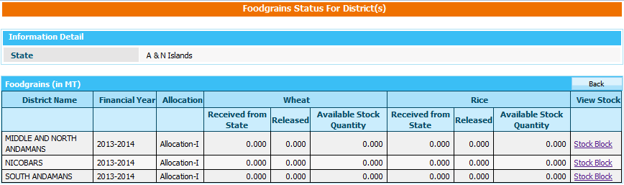

On click on link “Stock Block” it opens stock position for Block
It Shows the list of wheat & Rice to be Released to Block and from Block to School

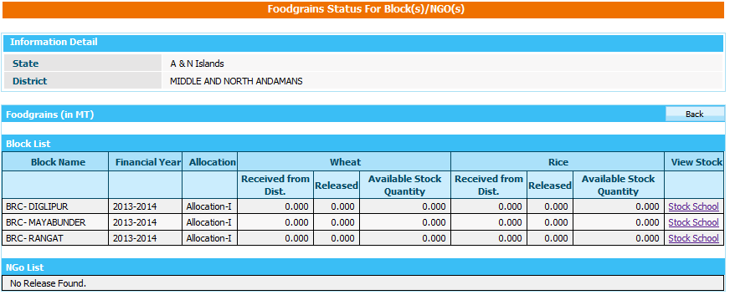

On click on link “Stock School” it opens stock position for School
It Shows the list of wheat & Rice to be Released from Block to School.

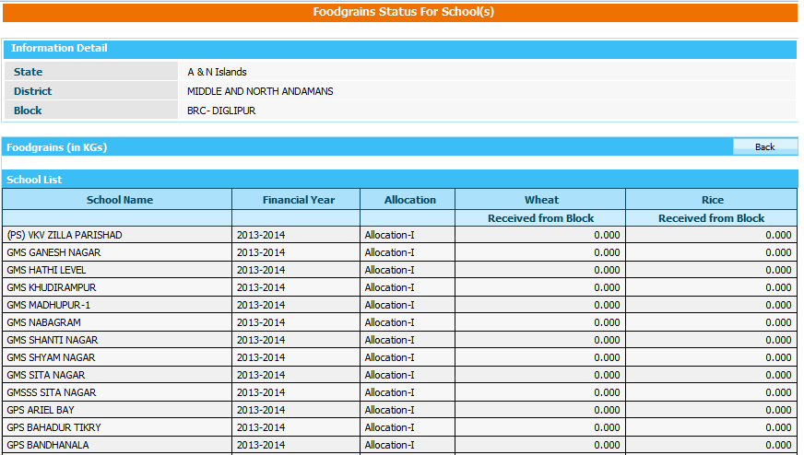

8. Food Grain Management

8.1 Indent Generation

User can view the indent created in following way.

User----> Select Financial Year---Search
List of all indent created will appear to user. User can view the data on clicking either Freezed or drafted link in data entry column.

To create new indent, click on Add new indent link, following screen will appear.

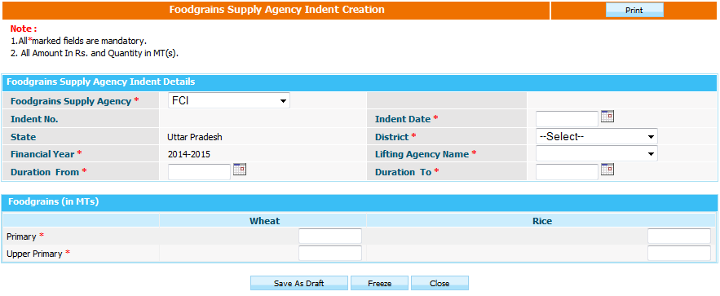

User have to select district for which user is going to create indent, lifting agency name, enters food grains data & can submit data either in Save As Draft or Freezed mode clicking on Save As Draft or Freezed button respectively.

8.2 Supply Agency Lifting Details

User can view the supply agency lifting details created in following way.

User----> Select Financial Year---Search
List of all supply agencies lifting created will appear to user. User can view the data on clicking either Freeze or drafted link in data entry column.

To create new supply agency lifting detail, click on Add new Supply agency Lifting Detail link, following screen will appear.

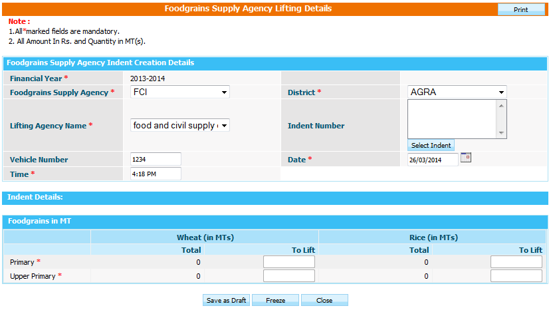

User have to select district for which user is going to create indent, lifting agency name, enters Food-grains data & can submit data either in Save As Draft or Freezed mode clicking on Save As Draft or Freezed button respectively.

8.3 Supply Agency bill Generation

User can view the supply agency bills made in following way.

User----> Select Financial Year---Search
List of all supply agencies bills made will appear to user. User can view the data on clicking either Freeze or drafted link in data entry column.

To create new Supply agency bill, click on Generate Bill link, following screen will appear.

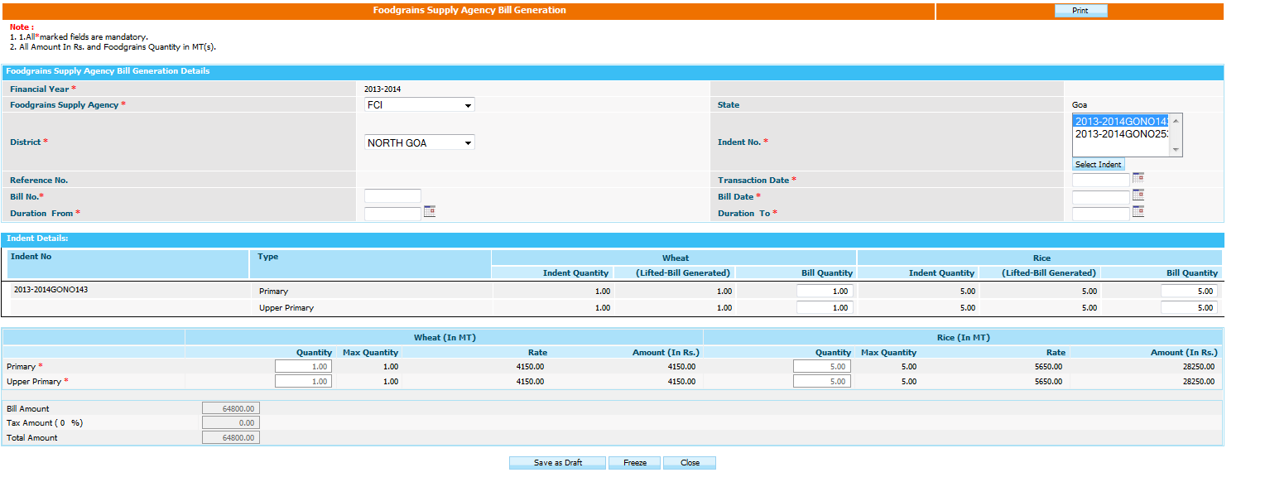

User--select District----Indents of that district will populate in Indents no.

User can generate partial payment or payments of multiple indents by selecting multiple indents or modifying the food grain amount in bill quantity column. As soon as user modifies the bill quantity payment of bill automatically changes.

User can save the bill either in Save as Draft or Freeze mode.

8.4 Supply Agency Bill Payments

User can view the supply agency bills Payment made in following way.

User----> Select Financial Year---Search
List of all supply agencies Payment made will appear to user. User can view the data on clicking either Freeze or drafted link in data entry column.

To pay the new Supply agency bill, click on Pay Bill link, following screen will appear.

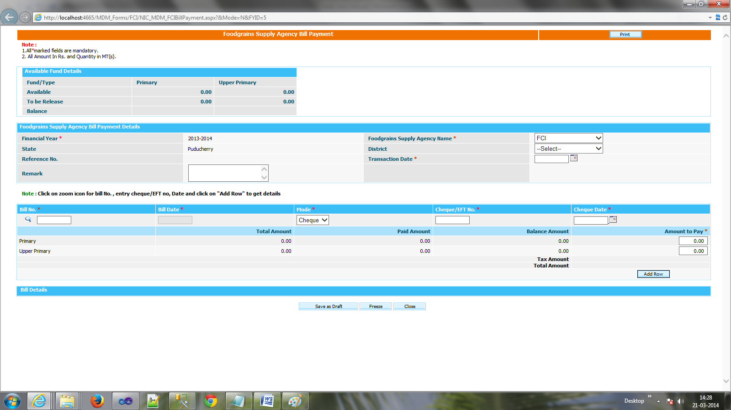

User--select District----Select bill no on clicking icon--enters bill date, mode--Add row
User can make the partial payment of bill by modifying Amount to pay or user can make payment of multiple bills by selecting another bill.
User can save the bill payment either in Save as Draft or Freeze mode

9. Lifting Agency

9.1 Bill Generation

User can view the lifting agency bills made in following way.
User----> Select Financial Year---Search
List of all supply agencies bills made will appear to user. User can view the data on clicking either Freeze or drafted link in data entry column.

To create new lifting agency bill, click on Generate Bill link, following screen will appear.

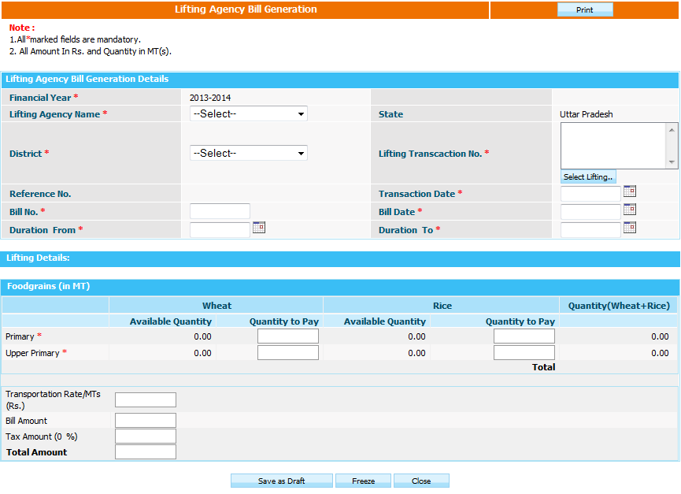

User--select District, Lifting agency----Lifting transaction no. of that district will populate in Lifting transaction no.

User can generate partial payment or payments of multiple Lifting transaction no by selecting multiple Lifting transaction no or modifying the amount in to be paid column. As soon as user modifies the bill quantity payment of bill automatically changes.

User can save the bill either in Save as Draft or Freeze mode.

9.2 Bill Payment

User can view the lifting agency bills Payment made in following way.

User----> Select Financial Year---Search
List of all lifting agencies Payment made will appear to user. User can view the data on clicking either Freeze or drafted link in data entry column.

To pay the new lifting agency bill, click on Pay Bill link, following screen will appear.

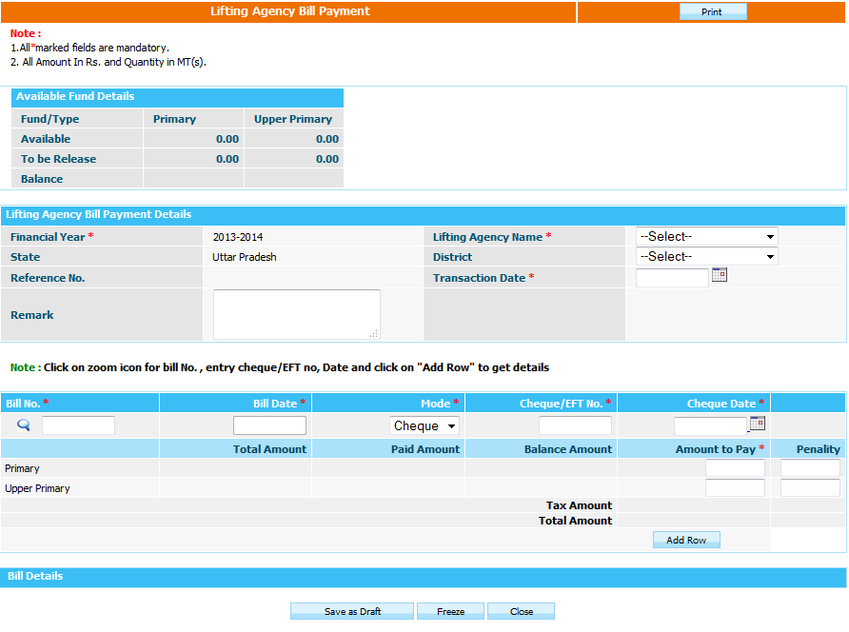

User--select District----Select bill no on clicking icon--enters bill date, mode--Add row
User can make the partial payment of bill by modifying Amount to pay or user can make payment of multiple bills by selecting another bill.
User can save the bill payment either in Save as Draft or Freeze mode

